**Developing a Scientific Calculator with Computation History**

**Members:**

**Agonoy, Alexis Greko F.**

([alexisagonoy0107@gmail.com](mailto:alexisagonoy0107@gmail.com))

**Bande, Meliza H.**

([melizahonorio0@gmail.com](mailto:melizahonorio0@gmail.com))

**Ragiles, Tristan Bren V.**

([tristan082300@gmail.com](mailto:tristan082300@gmail.com))

**Torralba, Laiza Marie P.**

**(**[**laizatorralba2@gmail.com**](mailto:laizatorralba2@gmail.com)**)**

**Valdez, Kate Ashley R.**

([kateashleyvaldez19@gmail.com](mailto:kateashleyvaldez19@gmail.com))

March 2024

1. **Introduction**

In today's fast-paced digital landscape, the demand for efficient tools is evident, particularly in the realm of mathematics and scientific computations. Traditional scientific calculators, while widely used, lack a crucial feature: the ability to maintain a computation history. This absence poses challenges for professionals and students alike, leading to loss of context in complex calculations, difficulty in error detection and debugging, and challenges in auditing and documentation.

Customer feedback and market trends emphasize the importance of this feature, highlighting a clear demand for scientific calculators with computation history functionality. Addressing these needs by developing a Scientific Calculator with Computation History is not only a wise investment but also a necessary step in meeting the evolving demands of users across various domains.

1. **Current Process Analysis**

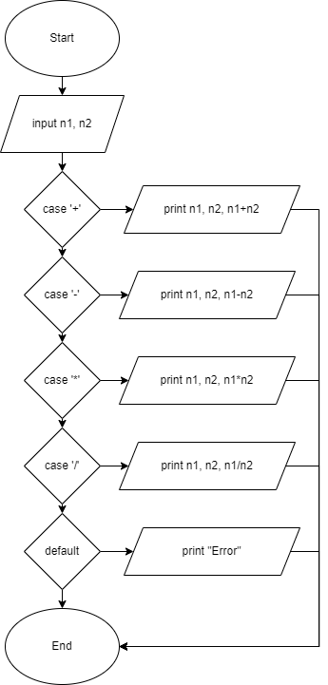

In this diagram after inputting n1 and n2 you will have the option to choose which case you will use and it will display the inputted number and its equal, then after getting the output the program will end

1. **Proposed Improvement**

The researchers encountered issues in this topic, such as the absence of a scientific calculator that saves the user's recent calculations. Therefore, the researchers proposed the following improvement to reduce the hassle for users: exploring different approaches, such as using a database engine to store recent calculations.

1. **Benefits & Impact**

There are several advantages in the fields of education, business, and research for creating a scientific calculator with computation history. This feature improves user experience and enables a range of applications in science, engineering, mathematics, and other fields. It also improves learning outcomes, efficiency, and accuracy.

* Enhance user experience
* Enhance learning experience
* Helps improve accuracy and efficiency
* Promotes collaboration in various settings
* Ensures transparency and reproducibility
* Fosters collaboration and facilitates communication
* Provides customization options
* Fosters the development of critical thinking and problem-solving skills
* Promotes inclusivity by catering to diverse learning styles and needs
* Drive advancements in technology and contribute to the evolution of educational tools and resources

1. **Project Plan & Timeline**

**Phase 1: Planning and Requirements Gathering**

Duration: 2 days

**Milestones:**

1. Define project scope and objectives.
2. Conduct market research to identify existing scientific calculators and features.

**Resources Needed:**

1. Project Manager
2. Programming Languages: HTML, CSS, JavaScript
3. Integrated Development Environments (IDEs): Visual Studio.
4. Version Control: Git

**Phase 2: Design and Prototyping**

Duration: 1 week

**Milestones:**

1. Design the user interface (UI) for the calculator, including buttons, layout, and display.
2. Create wireframes or mockups to visualize the interface.
3. Design the architecture for computation history storage and retrieval.

**Resources Needed:**

1. UI/UX designer (HTML & CSS)
2. Prototyping tools (Figma)
3. User testing participants

**Phase 3: Development**

Duration: 2 weeks

**Milestones:**

1. Develop core calculator functionality (basic arithmetic operations).
2. Implement scientific functions (trigonometric, logarithmic, etc.).
3. Integrate computation history feature.
4. Perform thorough testing and debugging.

**Resources Needed:**

1. Software developers (front-end and back-end)
2. Database engineer
3. Testing team

**Phase 4: Testing and Quality Assurance**

Duration: 1-2 weeks

**Milestones:**

1. Conduct functional testing of all calculator features.
2. Perform compatibility testing on different platforms and devices.
3. Address any bugs or issues identified during testing.

**Resources Needed:**

1. Testing tools
2. Devices for compatibility testing

**Phase 5: Deployment and Launch**

Duration: 1 week

**Milestones:**

1. Deploy the scientific calculator to a web server.
2. Perform final checks and optimizations.
3. Launch the project to the target audience.

**Resources Needed:**

1. Deployment tools
2. **Evaluation & Risk Assessment**

The project aims to enhance user experience with a scientific calculator by implementing improvements like saving recent calculations and employing a database engine for efficiency.

**Metrics and Methods:**

* User Satisfaction: Gather feedback via surveys and interviews.
* Usage Tracking: Monitor frequency and duration of calculator use.
* Error Rates: Track accuracy of calculations.
* Time Efficiency: Measure time taken for tasks.

**Potential Risks and Mitigation:**

* Technical Challenges: Thorough testing and updates.
* User Adoption: Clear documentation and incentives for feedback.
* Privacy and Security: Implementation of robust security measures and compliance with regulations.

1. **Conclusion**

Our proposal aims to develop a Scientific Calculator with Computation History, filling a crucial void in traditional calculators by introducing a feature that retains the history of calculations. This enhancement addresses the inefficiencies and challenges associated with the absence of computation history functionality, such as reduced efficiency, error detection difficulties, and auditing complexities. By leveraging approaches like utilizing a database engine to store recent calculations, our solution promises significant benefits across education, business, and research sectors.

It will elevate user experience, improve learning outcomes, enhance accuracy and efficiency, and foster collaboration among users. With a detailed project plan encompassing all phases from planning to deployment, alongside a thorough evaluation and risk assessment strategy, our proposal offers a robust framework for the development of this transformative tool. In essence, the Scientific Calculator with Computation History represents a paradigm shift in mathematical computations, aligning with evolving user demands and driving advancements in technology to meet the needs of professionals, students, and enthusiasts alike.